Name: Class:

Task 1

1. How many bytes are there in:
(a) 3 KiB?

(b) 2.5 MiB?

(c) 2 GiB?

(d) 4 Kib

2. For each of the binary values below, write down the denary equivalent. Use the grid below to help you.
(a) 1101

(b) 1111

(c) 00100110

(d) 10110111
128 | 64 | 32 | 16 | 8 | 4 | 2 | 1

3. What binary value is represented by the switches in the following circuit?
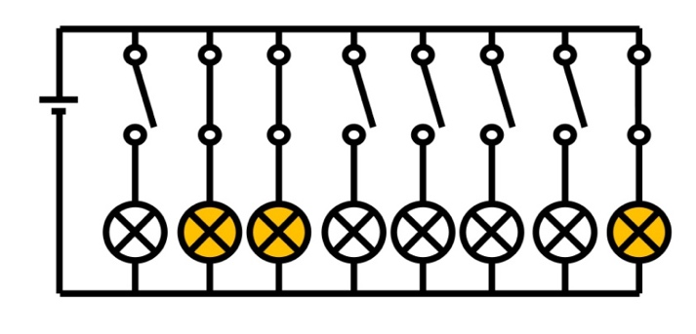

4. For the binary number 0110 1101, what is the value stored in:
(a) the most significant bit?

(b) the least significant bit?

Task 2

1. For each of the denary values below, write down the binary equivalent.
(a) 18

(b) 57

(c) 163

(d) 255

2. How many bytes would be needed to store the number 256?

Task 3
1. The questions below use 16 bits. Complete the place value headings in the grid for the 10th-16th bits. Then convert the following binary numbers to denary.
(a) 0001 1100 0111 0001

(b) 0010 0110 0010 0110

(c) 1111 1111 1111 1111

 |  |  |  |  |  |  |  | 128 | 64 | 32 | 16 | 8 | 4 | 2 | 1

(d) Convert 19,675 to binary using the table below:
 |  |  |  |  |  |  |  | 128 | 64 | 32 | 16 | 8 | 4 | 2 | 1

2. For each of the binary values below, write down the denary equivalent. Use the grid below to help you.
(a) 1 1011 1001

(b) 1011 0010 1010

(c) 1001 1101 1110 1001

(d) 1110 0101 1100 0001

3. For each of the denary values below, write down the binary equivalent.
(a) 152 109

(b) 18 325

(c) 56 603

(d) 65 535

Task 4

Fill in the blanks using the words beneath to complete the following paragraph.
A is made from a huge number of . These are used
to data. Each CPU will have a number of . Each one will store . When a calculation (processing) occurs, the results will also be stored in a register.
Registers Process Logic gates Binary data CPU

